# Lesson 2: Working with Scientific Notation and Units

## Essential Questions

How does scientific notation simplify the representation of extremely large and small numbers in science?

## Big Idea

Mastering scientific notation and consistent units is key for clear communication and accurate results in scientific work.

## Phenomenon

As the forensic chemist analyzes the bracelet to determine its authenticity, they must handle a wide range of measurements—from the mass of the entire bracelet to the microscopic thickness of the gold layer. These measurements vary from extremely large to incredibly small values. The chemist must use scientific notation to express these numbers clearly and accurately, ensuring that all measurements are in the correct units for proper comparison. Small errors in notation or unit conversions could lead to incorrect conclusions about whether the bracelet is made of real gold or a cheaper, gilded metal. Understanding how to properly use scientific notation and units are essential to solving the case.

## Vocabulary

Ampere

Base Units

Candela

Dimensional Analysis

Meter

Kelvin

Kilogram

Mole

Scientific notation

Second

SI Units

## Lesson Objectives

By the end of the lesson, I will be able to:

• Express numbers in scientific notation.

• Perform dimensional analysis to convert units.

• Develop a method to convert between different units using dimensional analysis.

## Ignite

The forensic chemist is measuring two things about the stolen bracelet:

The total mass of the bracelet, which is about 100 grams.

The thickness of the gold layer, which could be as small as 0.000001 meters.

How can the chemist express both of these numbers clearly, so they are easy to work with?

Why is it important to use a system that handles both large and small numbers without confusion?

## ~~Direct Instruction~~

The forensic chemist is trying to figure out whether the recovered bracelet is made of real gold or a cheaper metal. One way to do this is by measuring the density of the materials. The chemist must use accurate measurements and scientific notation to handle very large or small numbers. They also need to convert units correctly to make sure all the calculations are consistent.

## Progress Check 1

1. Why is it important for the forensic chemist to use scientific notation when working with numbers like 19.32 g/cm³?
2. How might unit conversion be helpful if the chemist needs to compare measurements in different systems, like grams to kilograms?

## ~~Pathfinder (Explore)~~

Lab Experiment: Investigating Density Using Scientific Notation and Unit Conversion

Materials

Graduated Cylinder

Balance (digital balance)

Thermometer

Unknown liquid sample

Pipette or dropper

Procedure

1. Measure and record the mass of an empty graduated cylinder using a balance.

2. Add a known volume (e.g., 50 mL) of the unknown liquid to the cylinder and record the new mass.

3. Calculate the mass of the liquid by subtracting the mass of the empty cylinder from the total mass.

4. Record the volume of the liquid from the graduated cylinder and use the formula, Density = Mass/Volume to calculate the density.

5. Repeat the measurements to ensure accuracy and precision.

6. Report your findings with the correct number of significant figures.

7. Present your density calculation using scientific notation.

8. Convert the density into Kg/L.

## **~~Lightbulb (Explain)~~**

In our investigation of the stolen bracelet, the forensic chemist must be precise in measuring and analyzing data. To do this, they rely on scientific notation and SI units to express numbers accurately and convert between different units during the analysis. Let’s explore how these concepts help the chemist and you as a student working with scientific measurements.

**Scientific Notation**

In forensic chemistry, scientists often deal with extremely large or small numbers, like the total mass of a bracelet or the thickness of a gold layer. Scientific notation simplifies these numbers, making them easier to work with and preventing calculation errors. For example, a tiny thickness of 0.000001 meters can be expressed as 1 × 10⁻⁶ meters, making it easier to read and calculate.

Why is scientific notation important when working with very small or very large numbers?

**SI Units**

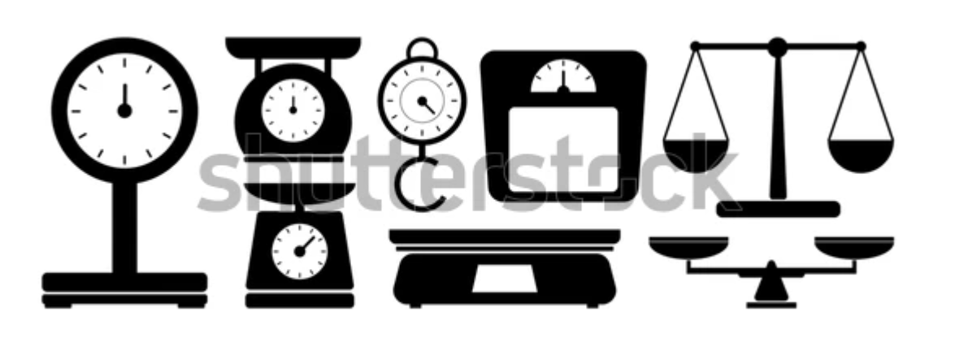

Figure 1.x: Unit Measurements

The SI Units (International System of Units) are standardized units used across the world to ensure consistency in measurements. In the lab, the chemist uses these units to ensure accuracy.

**Ampere (A):** Measures electric current, important in testing the conductivity of metals, which might be relevant when verifying the authenticity of the gold in the bracelet.

**Meter (m):** Measures length or distance. In our lab, we use meters to express the thickness or size of the bracelet components.

Why is it necessary to measure the size or thickness of objects in meters when working with jewelry like a bracelet?

**Kilogram (kg):** The base unit of mass. While the bracelet's mass might be measured in grams, converting it to kilograms is key for standardization.

What would be the advantage of reporting the bracelet's mass in kilograms rather than grams?

**Second (s):** The SI unit of time, essential for precise time measurements in experiments.

**Kelvin (K):** Measures temperature, which could affect the density and properties of the bracelet’s materials.

**Mole (mol):** The base unit for the amount of substance. Although less directly related to the bracelet analysis, moles are used when measuring chemical quantities.

**Candela (cd**): The SI unit for luminous intensity, relevant if examining how gemstones reflect light.

**Dimensional Analysis and Unit Conversion**

Dimensional analysis is a tool to convert between different units using conversion factors. This ensures that all measurements are expressed in the same units for easier comparison and analysis. For instance, converting grams to kilograms or centimeters cubed (cm³) to liters ensures consistency in calculations like density. The chemist might need to convert the density from grams per cubic centimeter (g/cm³) to kilograms per liter (kg/L).

**Perform Dimensional Analysis**

To convert units, follow these steps:

Write down the value you want to convert.

Multiply by a conversion factor, ensuring units cancel out appropriately.

Continue multiplying by conversion factors until you reach the desired unit.

For example, converting the density of gold from g/cm³ to kg/L: 1 g/cm³ × (1 kg / 1000 g) × (1000 cm³ / 1 L) = 1 kg/L.

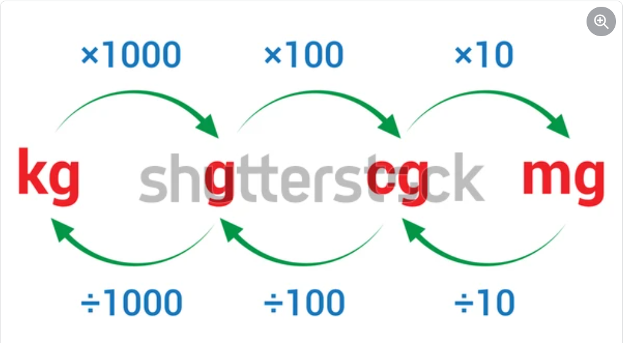

How can dimensional analysis help when comparing measurements in different unit systems?

## Progress Check 2

1. You measured the volume of a liquid as 150 mL using a graduated cylinder. Convert this volume into cubic centimeters and express your answer in scientific notation. ~~(DOK 2)~~
2. Imagine you have a sample of an unknown metal with a mass of 0.0025 kilograms. Convert this mass into grams and express it in scientific notation. ~~(DOK 2)~~

## ~~Power Up~~

Reflect on the following prompts to think critically about the content and come up with meaningful questions for inquiry about scientific notation and units.

* Different units can represent the same quantity.
* Scientific notation simplifies the representation of very large or very small numbers.
* Unit conversions are essential for accurate measurements.
* The choice of units can affect the interpretation of data.
* Understanding significant figures is important when using scientific notation.

## **Progress Check 3**

1. Why is it important for the forensic chemist to use correct units when measuring the mass and volume of materials in the bracelet investigation? How would misusing units affect the analysis of the gold and cubic zirconia stones? ~~(DOK 3)~~
2. ~~In the bracelet case study,~~ the forensic chemist measured the mass of a gold sample as 0.0193 kilograms. Convert this mass into grams. ~~(DOK 1)~~
3. Convert the number 4,500 to scientific notation. ~~(DOK 1)~~
4. Given the measurements 3.0 m and 2.5 m, calculate the total distance and express your answer in scientific notation. ~~(DOK 2)~~
5. Design a scenario where you would need to convert units (e.g., from meters to kilometers) and apply scientific notation to express your answer. What steps would you take? ~~(DOK 3)~~
6. Which of the following represents the correct conversion of 0.0035 kilograms into grams, expressed in scientific notation?

$3.5× {10}^{1} grams$

$3.5× {10}^{\left\{2\right\}}grams$

$3.5×{10}^{\left\{3\right\}} grams$

$3.5× {10}^{\left\{4\right\}}grams$

## Going Beyond!

Scientific notation and unit conversion are not only essential in the lab but play a vital role in many aspects of our daily lives. These concepts simplify calculations involving extremely large or small numbers, which we encounter in fields such as astronomy, engineering, and finance. For example, when discussing the vast distances between planets or the minute measurements in nanotechnology, scientific notation makes these numbers easier to manage and understand. In finance, it helps simplify large transactions or population statistics.

Unit conversion is equally important in areas such as travel, where converting between miles and kilometers is crucial, or in cooking, where recipes might require switching between grams, ounces, or cups. Understanding how to accurately convert units helps ensure consistency, whether you're following a recipe or determining the correct dosage of medicine.

In the context of sustainability and environmental awareness, converting energy usage data or carbon footprints from different units allows individuals and organizations to measure their impact on the environment more clearly. Mastering scientific notation and unit conversion empowers people to make informed decisions in both everyday tasks and critical global issues, contributing to a better understanding of the world.